Character Sheet

\*Name: Abdel As-Saffah

+Age: 34

+Weight: 171

+Height: 6’0

\*Party Affiliation: SNRPP

\*Personality: lighthearted, *muslim*

+Likes: serving Allah, reading industrial society and its future

+Dislikes: (((them)))

\*Description(Or Image):

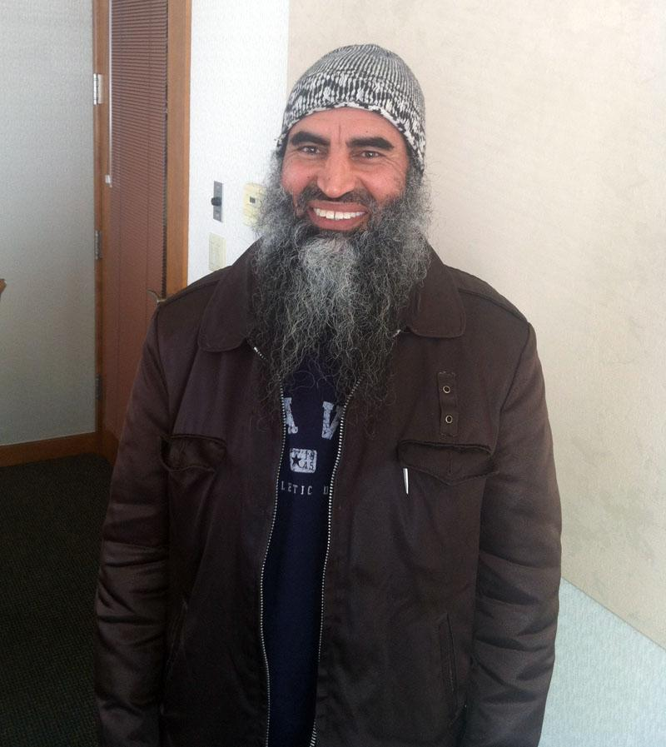

\*Bio: came from Esnen to evade what ever the Oceanas had in mind. Doesn't trust the eastern half of the world bc they are imperialist bastards. Moved to Patrium because he enjoys democracy and also read somewhere that it had good job opportunities and he could give his wheat and poppy farming family some good money.